Quadratic Links 1
Matching
The following ‘cards’ are in no particular order
Use the cards, either by cutting them out or by labeling, to create 6 groups. Each graph card has 4 corresponding text cards that go with it!

An example of what a finished group might look like is shown below

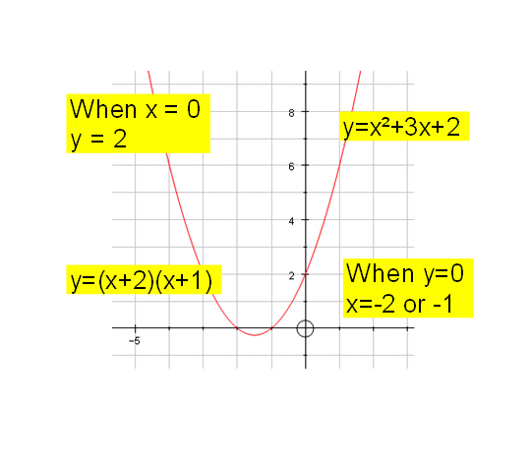
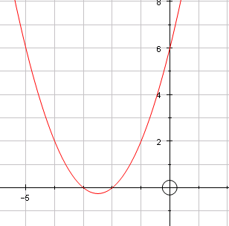 | 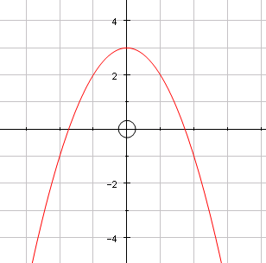
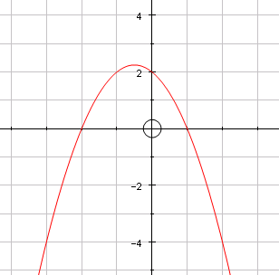 | 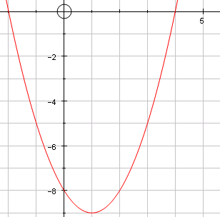
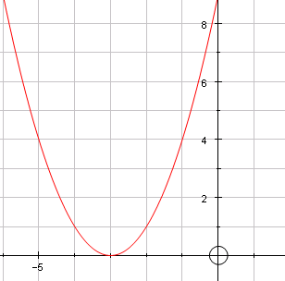 | 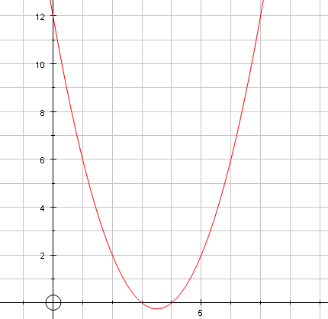

y= x² + 5x + 6 | y = (x + 3)² | When x = 0,  y = -8 | When y = 0,  x = 4 and - 2
y= -x² + 3 | y= (x – 3)(x – 4) | When x = 0,  y = 3 | When y = 0,  x = 1 and - 2
y= x² - 2x - 8 | y= (x – 4)(x + 2) | When x = 0,  y = 6 | When y = 0,  x = 4 and 3
y=x² + 6x + 9 | Cant be factorised | When x = 0,  y = 2 | When y = 0,  x = -3
y=x² - 7x + 12 | y= (x + 2)(x + 3) | When x = 0,  y = 9 | When y = 0,  x = + and -
y= -x² - x + 2 | y= (-x + 1)(x + 2) | When x = 0,  y = 12 | When y = 0,  x = -3 and - 2

